Internal Travel System (ITS) – Project Proposal

|  |  |  |
| --- | --- | --- |
| Course | ITEC 640 – Information Technology Project Management | |
| Document | Group Project – Project Proposal (Assignment #1) | |
| Semester | Spring 2020 | |
| Group # | 4 | |
|  | | |
| Team Member Name | Assigned Section | Internal Due Date |
| Brittany Kircher | Introduction | 02/21/2020 |
| Didimus Kimbi | Statement of Need | 02/21/2020 |
| Eugene Kim | Project Definition | 02/21/2020 |
| Debashis Jena | High Level Approach | 02/21/2020 |

# Introduction

Enterprise application system that enables users to book travel, including air, hotel, car & expense their travel (within one application). The application allows travel arrangers or employees to compare and contrast pricing to make the best decision (fiscally) and track and allocate spending.

Key notes to think about:

1. Creates standardization to put in place standard operating procedures
2. Decreases complexity of IT systems and duplication of work for stakeholders to research travel
3. Integrates IT with business operations, enabling employees to quickly meet the needs of customers. That is, employees will depend on a system that delivers quick, innovative solutions to travel so they can focus on what matters: the business

________________

Silver Springs, LLC is a Maryland-based, medium-sized business that delivers innovative IT solutions, specializing in project management practices and principles, and has a community standing for being known as a trusted, innovative source. The company has a successful track record of delivering multi-million-dollar solutions on time and within budget and prides itself on its customer-relationship management by maintaining face-to-face client interaction. However, the company has been facing significant challenges because of the lack of internal standard operating procedures and technological limitations leading to unsustainable costs for its travel system. To continue thriving as a company, Silver Springs, LLC must invest in new technologies and processes.

Advances in technology, such as Cloud enterprise systems, have made it possible for businesses to create and successfully maintain standardization, improve security, and reduce costs. As an example, Amazon Web Services has established itself to be the leading Cloud Service Provider for enterprise applications by proving its adaptability and forward-leaning technologies, providing a multitude of businesses with solutions never before possible. These advancements have created an opportunity for Silver Springs, LLC to utilize a platform that can establish proper security protocols, interoperability between its departments, and streamlined business processes. Cloud services will enable on-demand, secure, and scalable infrastructure as the company continues to grow. Silver Springs, LLC must capitalize on these technological advancements to stabilize its cost and improve infrastructure.

Silver Springs, LLC will embark on a journey to build an enterprise-wide centralized travel system to modernize its infrastructure, reduce overhead and travel costs, and create standard operating procedures. One modernization project that was conducted a year ago, the implementation of the enterprise-wide Office 365, has already proven to reduce overhead costs, standardize practices and procedures, and create interoperability within the company. Silver Springs, LLC will capitalize on this past success to build a next-generation travel system that will meet the organization’s needs for a secure, high-performing environment. The travel system will be implemented within the company by using Agile methodologies, which will enable the team to capture user stories and implement first-class technological solutions.

Key guiding principles for this project will provide structure and agility for designing and building. These guiding principles serve to provide structure to the project’s vision.

1. Scalability: as the company grows, it expects more employees to utilize the travel system. The system should be scalable to accommodate users as needed.
2. Availability: information should be available on-demand and provide a wide array of tools.
3. Automation: all aspects of travel, including invoicing and payment, should be in one system.
4. Governance: the system should allow and provide management of travel data and traceability of costs.
5. Standardization: standard operating procedures should be created and maintained.
6. Security: maintain security standards to protect user and company sensitive information.

__________________________

Because of the company’s success, it has attracted notice from several big firms and has won contracts across multiple states; its most recent contract win is in California. The new contract will require frequent travel for its employees to attend in-person business meetings with clients. After performing an as-is analysis, the company found that a system of checks and balances for its travel system is severely lacking and that employees were not booking travel that is advantageous to the company. As a result, the company has elected to assign a team to resolve this issue by building an enterprise travel system to meet the needs of its employees while being fiscally responsible. The company’s CFO intends to assign a project manager from within the company to manage the project, and the CFO will also provide the necessary resources from within the company to work in the functional environment.

# Statement of Need

This document is a project proposal that identifies the need for the company travel system. The company travel system service should be considered due to the problems encountered by organization employees during travel. Employee travel management take on time and resources, automating part of the system by the implementation a travel system will be smooth ease travel management while streamlining the experience. The increased number of organization activities and business growth has led to travel problems for the organization. The increased travels should not be management or with the current system manually. With increasing number of employees, it has become difficult to manage the travel plans which indirectly affect operation throughout the company. Situations that require travel should have minimal impact on overall operations while also providing seamless and freedom to employees.

Budget constraints have become noteworthy, since there is no clear system for accountability and delays in travel planning, the automation of this process through the implementation of the company travel system will lead to saving money and time. Unlocking the companies hidden potential and new opportunities for where to enhance performance. The optimized costs through the automation will reduce human errors since the travel system will be more accurate and faster in carrying out the tasks. The administrative tasks such as data collation, searching and data mining will be easy to handle through the system. This will reduce delays, errors and inaccuracies. Employee satisfaction should increase if the travel system streamlines the intricacies of the travel processes from trip booking, collating expenses, generation of yearly reports and analysis. Through the travel system the company will have a greater visibility of the spending involved, the company will be able to track the corporate travels in real time. The greater visibility into the company spending patterns will help the organization measure related performance targets. The travel system will enable the organization to analyze travel patterns, determine business opportunities continuous improvement and predict business growth.

Through the company travel system the company should have a defined travel policy, that will help the organization. The travel policy will lead to trusted culture in the organization whereby the employees will be more involved in the process, employees will gradually avoid outdated methods used by the organization. With the company travel system everything will be centralized which will ensure that all corporate travelers adhere to the set travel policy while being in control of their trip. The communication, approvals, bookings and invoices will be in one centralized roof, saving time and improving the business operations. Enough visibility and flexibility to allow for personal growth by making connections and learning new things during their travel. This will help the company maintain a satisfied work force by valuing the talents. Visibility also enhances the security and safety of travelers. The travel system will be able to update the risk areas with GPS tracking to help the organization keep a constant communication link with employees at all time while on travel.

An importantly, the simplification of expense management, as the manual process of tracking travel expenses can and has been a rigorous process for company. With a digital footprint and shared documents, loss of documents by employees for tracking expenses is eliminated, so a significant cause of problems will also not be an issue with the new system. With this system the employees will be able to track in real time their spending and can access the spending reports anywhere. The company will simplify the expense management, prioritize and dedicated resources into new projects that promote and grow the business.

# Project Definition

# Stakeholders

The following stakeholders will need to be involved during the project with their corresponding responsibilities:

1. Board of Directors
   1. Chief Executive Officer
      1. Oversees project and ensures success of the company
   2. Chief Financial Officer
      1. Manages finances and ensures that the new system fits within the company’s financial goals
   3. Chief Technology Officer
      1. Manages technical vision and ensures that project is built with high technical standards and procedures
2. Project Management Team
   1. Schedule project milestones and report to board of ongoing activities
   2. Ensures work is accomplished in a timely manner
3. Engineering Teams
   1. Front End
      1. Focused on building user interface and implementing UX methods to maximize user satisfaction
   2. Backend
      1. Support frontend by providing data and server support to run applications
   3. IT Support
      1. Will provide ongoing support for system users and help to troubleshoot or diagnose any IT related problems with the system
   4. Both engineering teams will report to project management team of ongoing progress and follow technical vision and architecture as specified by the CTO
4. Accounting Department
   1. User of the service to properly reimburse any outstanding balances.
   2. Will test system as part of project tasks
   3. Will need to integrate a new process to utilize the new service into their existing business process
   4. Provide timely feedback on tool as development occurs
5. Management Department
   1. User of the service to approve any open expense reports
   2. Will test system as part of project tasks
   3. Will need to integrate a new process to utilize the new service into their existing business process
   4. Inform members of their team to utilize new tool
   5. Provide timely feedback on tool as development occurs
6. Employees
   1. User of the service to book and request approval for travel
   2. Will test system as part of project tasks
   3. Will need to integrate a new process to utilize the new service into their existing business process
   4. Provide timely feedback on tool as development occurs
7. Third Party Vendors
   1. Airlines
   2. Hotels
   3. Transportation
   4. All third-party vendors may need to be aware that the project will affect the existing system and any negotiations or agreements with third party vendors must be reflected within the new project and continued to be updated within the new system.
   5. All vendors must be available for users to book travel with

# User Requirements

This project will be an online web application that users will be able to access after being authenticated as an official user. The user requirements are as follows:

1. User should be able to book travel
2. User should be able to submit expense for reimbursement
3. Authorized users should be able to approve or deny expense reports for their employees
4. Authorized users should be able to review and submit reimbursement for approved expense reports.

Project success will be determined with the following performance metrics:

* + - 1. Service adoption metrics will be determined by number of unique users booking travel through the site and captured on a monthly basis.
      2. Number of expense reports submitted, approved, and reimbursed.

This project will aim to achieve 100% user adoption within 6 months after finishing the project.

The final requirement for this project is to ensure that documentation of the service exists and thoroughly details the service architecture and tools. The documentation should include a detailed specification of the service, a tutorial to utilize the service for every type of user (employee, manager, and accountants), and a support guide to diagnose and troubleshoot any arising issues. This documentation will be delivered to all stakeholders for review and be presented to system users in a live session so that all users are able to use the system as intended.

# System Requirements

The system will need to be available and accessible at all times because a user may submit, review, or reimburse an expense report in any given time. The booking system should have a built-in query system that pulls from a database of various booking options. The user experience should be quick, and downtime should be minimized as much as possible. Because this is a new system for travel invoicing, it should not interfere with any existing systems within the company; however, it should be built in a way such that future improvements or modules can be attached to the service. For example, integrating the service with the company’s online calendar and email system.

Necessary system and security updates will be performed on Wednesdays between 3am to 5am EST in order to minimize downtime for users. Automated testing will also be put in place to ensure that the service runs as expected after any updates. The tool should also have a support page that can link users to IT support if they run into any issues.

# High Level Approach

The scope of this project is to automate the travel system for the internal employees and the reimbursement process of the expenses. The current process which is purely manual and involves many defined steps for the employees and the accounting team will be automated and can be accessed via an internet browser or a mobile application. ITS will be comprised of sub-modules.

# Application Features

This product may be broken down into the following user groups and high-level features.

# User Profiles

User contexts for ITS may vary by profiles. The key users for this system can be classified into four profiles.

1. Travelers – Users who will book their travel and request approval for reimbursement
2. Managers / Approvers – Approves the reimbursement request
3. Accounting – Reimburses the travel expenses
4. Administrators – Setup users and configurations

# Modules

ITS can be broken down into the following areas.

1. Front End
   1. Travelers view
   2. Approvers view
   3. Accounting view
   4. Admin view
2. Back End
   1. ITS Main – Salesforce can be used for the following.
   2. Reservation module Integration with Salesforce – Many COTS products are available to build out this module. Instead of building this feature from scratch, any third-party solutions can be utilized for this purpose. For example, companies like TripAdvisor, Rezdy or TrekkSoft provide APIs for an enterprise travel system. The selection of the software will be based on budget and usability.
   3. Integration with Payroll system – For the reimbursement process the ITS Main needs to be integrated with the current payroll system.
   4. Amazon Web Service (AWS) platform – The backend databases, APIs and jobs which are required to support the processes which are external to Salesforce can be created within AWS.

# Work Breakdown Structure

These modules are needed to be tightly coupled with each other. An iterative development process can be followed to develop the application features described in the following section. This development process will help the project to deliver application functionalities incrementally and continuously to the customer.

# Meetings with Stakeholders and Users

As the stakeholders are identified, the meetings will be conducted to gather more information about the intended project.

# Requirement Analysis and Evaluation

The business analysts and some of the development leads will gather around to understand the requirements and evaluate the same to prepare for the design.

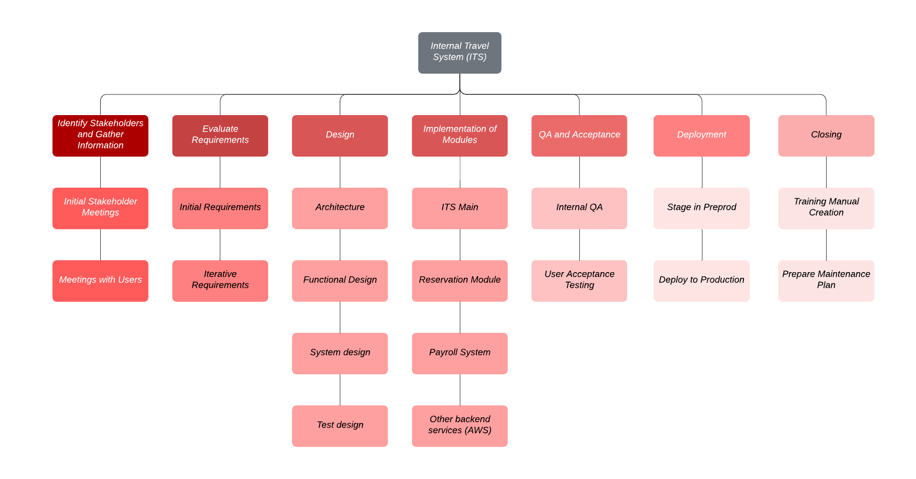

# Design

Functional and system design documents will be created with keeping in mind that there may be future requirement changes and security of the entire application. Simultaneously, the testing team will come up with the plan for the system testing.

# Implementation Activities

Each of the above-mentioned modules will be created and integrated.

# Quality Assurance (QA) and Acceptance

This is the phase where the application functionalities are validated against the defined requirements. Also, the user acceptance testing of ITS is done in this phase where users get to test the application in a non-production environment.

# Deployment

As the ITS development is complete and user acceptance testing is successfully complete, the application will be deployed to the production environment.

# Closing – Training and Maintenance

This is the last phase of the first release where the acceptance criteria will be validated with the customers. As the criteria are successfully met, the project will be assumed to be complete. Then a formal training will be provided to the users. Additionally, a maintenance team can be deployed for any future issues or enhancements.

Reference:

1. Ambriz, Rodolfo & White, John. (2011). *Dynamic scheduling with microsoft project 2010: the book by and for professionals.* Retrieved from *http://library.books24x7.com.ezproxy.umuc.edu/toc.aspx?bookid=45426*.
2. Olson, D. (2015). Information Systems Project Management. *Project Selection and Approval*. (pp. 47-54)